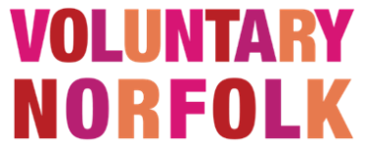  Voluntary Norfolk is committed to both the principle and the practice of Equal Opportunities and we welcome applications from all parts of the community regardless of gender, physical ability, nationality, race, religion, or sexual orientation.  We know that people from different age groups bring varying levels of expertise and experience to an organisation and we are always keen to receive applications from every candidate with relevant skills and qualifications, regardless of age.  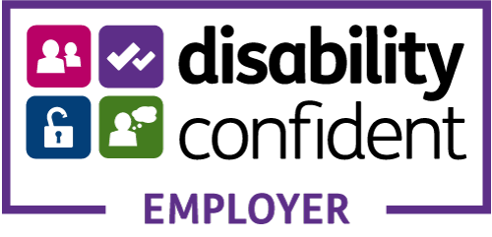  Voluntary Norfolk is a registered charity no. 1112017.  Registered as a company limited by guarantee in England and Wales no.5616120. Registered address  St Clements House, 2-16 Colegate, Norwich NR3 1BQ | We are looking for a dedicated individual to join our Better Together Norfolk Team in the following position:  Life Connector & Volunteer Co-ordinator – South Norfolk  Better Together Norfolk  Full time 37 hours per week  As part of a multi-disciplinary team, provide flexible and responsive one-to-one person-centred support to individuals at risk of, or experiencing, loneliness and social isolation. Deliver interventions, which are responsive, to the needs of clients, meeting what matters to them, and promote social inclusion and positive wellbeing.  To work with the Better Together Team and South Norfolk and Broadland District Councils and other team members to continuously improve the volunteering opportunities and coordinate a team of volunteers to meet agreed targets in line with approved Voluntary Norfolk (VN) policies and procedures  Post is offered until 31st March 2023  Salary: £23,838 per annum  Base: South Norfolk Help Hub, Long Stratton.  A hybrid working policy is in development.  Closing date: Monday 31st January 2022 at noon  Interview date: Friday 4th February 2022  To apply please download an application pack from:  www.cbrsolutions.org.uk/jobs-board  For further information about this post  please contact David Crinson on 07917490223 or  david.crinson@bettertogethernorfolk.org.uk

